

**Name Nadeem ullah**

**Sap id 56031**

**Semester CS3-2**

Question 1

#include <iostream> using namespace std;

int main() { int ages[10], largestAge = 0;

cout << "Enter the ages of 10 students:\n";

for (int i = 0; i < 10; i++) { cin >> ages[i];

if (ages[i] > largestAge) { largestAge = ages[i];

}

}

cout << "The largest age is: " << largestAge << endl;

return 0;

}

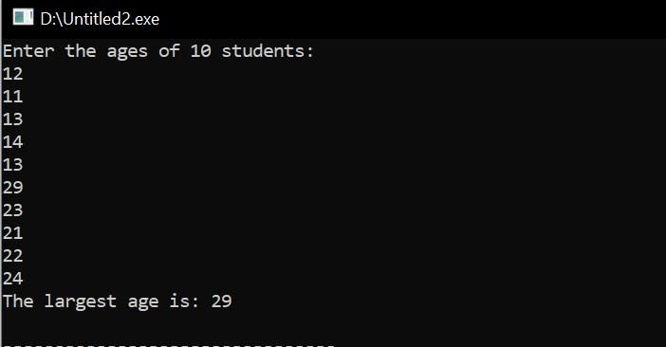

Question 2

#include <iostream> using namespace std;

int main() {

int n;

cout << "Enter size of the arrays: "; cin >> n;

int arr1 = new int[n]; int arr2 = new int[n]; int arr3 = new int[n]; int result = new int[n]; cout << "Enter elements of first array: ";

for (int i = 0; i < n; i++) { cin >> arr1[i];

}

cout << "Enter elements of second array: ";

for (int i = 0; i < n; i++) { cin >> arr2[i];

}

cout << "Enter elements of third array: ";

for (int i = 0; i < n; i++) { cin >> arr3[i];

}

for (int i = 0; i < n; i++) { result[i] = arr1[i] + arr2[i] + arr3[i];

}

cout << "Resulting array: ";

for (int i = 0; i < n; i++) { cout << result[i] << " ";

}

cout << endl;

return 0;

}

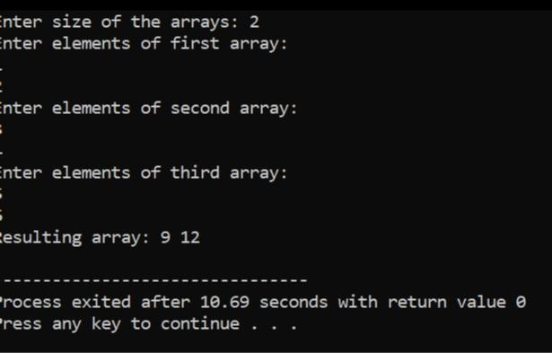

**Question 3**

#include <iostream> using namespace std;

int main() { int n, item, pos = -1;

cout << "Enter the size of the array: "; cin >> n;

int arr = new int[n];

cout << "Enter " << n << " elements of the array: ";

for (int i = 0; i < n; i++) { cin >> arr[i];

}

cout << "Enter the item to search: "; cin >> item;

for (int i = 0; i < n; i++) { if (arr[i] == item) { pos = i;

break;

}

}

if (pos != -1) {

cout << "Item found at position: " << pos << endl;

}

else {

cout << "Item not found in the array." << endl;

}

delete[] arr;

return 0;

}

